Axel Van Dyck, Grupo 14, sprint 6

Ejercicios para consultas en bases de datos y manejo de consola.

# **Consola**

## **Ejercicio 1**

El comando o secuencia de comandos que te proporcionó los registros necesarios:

1. : $ grep -R "^233.201" ~/logs/2019/12

Registros:

233.201.188.154 - - [18/12/2019:21:46:01 +0000] "DELETE /events HTTP/1.1" 403 3971

233.201.182.9 - - [21/12/2019:21:56:20 +0000] "PATCH /users HTTP/1.1" 400 4118

## **Ejercicio 2**

Comandos que crean los directorios bug1 y events:

$ mkdir ~/bug1

$ mkdir ~/bug1/events

$ cd ~/bug1/events

$ touch 400.txt 500.txt

El comando que usas para seleccionar las solicitudes para un periodo especificado. Estas son las solicitudes que usas para obtener registros en el archivo main.txt:

1. $ grep ~/logs/2019/12/apache_2019-12-30.txt > ~/bug1/main.txt

Los comandos que usas para colocar los registros en los archivos 400.txt y 500.txt del main.txt:  
$ grep " 400 " ~/bug1/main.txt > ~/bug1/events/400.txt

$ grep " 500 " ~/bug1/main.txt > ~/bug1/events/500.txt

400.txt  
172 Lineas

80.57.170.51 - - [30/12/2019:21:35:12 +0000] "DELETE /users HTTP/1.1" 400 3623

204.235.176.118 - - [30/12/2019:21:35:13 +0000] "POST /users HTTP/1.1" 400 4704

82.95.203.67 - - [30/12/2019:21:35:19 +0000] "DELETE /lists HTTP/1.1" 400 3737

155.242.215.46 - - [30/12/2019:21:35:38 +0000] "POST /playbooks HTTP/1.1" 400 4450

189.176.85.0 - - [30/12/2019:21:35:39 +0000] "PATCH /alerts HTTP/1.1" 400 2732

13.108.71.71 - - [30/12/2019:21:35:43 +0000] "PATCH /events HTTP/1.1" 400 3410

195.213.133.182 - - [30/12/2019:21:35:46 +0000] "PUT /customers HTTP/1.1" 400 3085

235.243.133.78 - - [30/12/2019:21:35:47 +0000] "PATCH /customers HTTP/1.1" 400 3264

192.57.115.49 - - [30/12/2019:21:35:55 +0000] "POST /parsers HTTP/1.1" 400 2457

71.0.49.244 - - [30/12/2019:21:35:55 +0000] "PUT /collectors HTTP/1.1" 400 2785

224.159.206.126 - - [30/12/2019:21:36:02 +0000] "DELETE /customers HTTP/1.1" 400 4569

131.35.106.246 - - [30/12/2019:21:36:04 +0000] "DELETE /lists HTTP/1.1" 400 2578

216.24.42.208 - - [30/12/2019:21:36:06 +0000] "GET /parsers HTTP/1.1" 400 4597

123.53.150.160 - - [30/12/2019:21:37:19 +0000] "PATCH /events HTTP/1.1" 400 4379

61.129.127.103 - - [30/12/2019:21:37:32 +0000] "GET /lists HTTP/1.1" 400 2575

90.216.4.78 - - [30/12/2019:21:37:34 +0000] "PATCH /lists HTTP/1.1" 400 3899

204.250.214.208 - - [30/12/2019:21:37:36 +0000] "PATCH /parsers HTTP/1.1" 400 4742

79.214.240.98 - - [30/12/2019:21:37:37 +0000] "POST /fieldsets HTTP/1.1" 400 4441

65.47.42.12 - - [30/12/2019:21:37:39 +0000] "PATCH /customers HTTP/1.1" 400 2500

251.118.141.34 - - [30/12/2019:21:37:41 +0000] "POST /customers HTTP/1.1" 400 3519

205.20.166.196 - - [30/12/2019:21:37:51 +0000] "POST /users HTTP/1.1" 400 4032

156.217.3.46 - - [30/12/2019:21:37:52 +0000] "PATCH /parsers HTTP/1.1" 400 2020

48.240.198.167 - - [30/12/2019:21:37:57 +0000] "PATCH /playbooks HTTP/1.1" 400 4100

101.255.159.211 - - [30/12/2019:21:37:59 +0000] "GET /auth HTTP/1.1" 400 2324

80.76.98.203 - - [30/12/2019:21:38:00 +0000] "POST /playbooks HTTP/1.1" 400 3045

85.64.63.255 - - [30/12/2019:21:38:13 +0000] "PATCH /collectors HTTP/1.1" 400 2291

184.79.247.161 - - [30/12/2019:21:38:13 +0000] "PUT /alerts HTTP/1.1" 400 3557

93.2.134.22 - - [30/12/2019:21:39:39 +0000] "DELETE /alerts HTTP/1.1" 400 3701

96.181.163.104 - - [30/12/2019:21:40:05 +0000] "GET /auth HTTP/1.1" 400 3742

214.73.245.219 - - [30/12/2019:21:40:07 +0000] "PATCH /customers HTTP/1.1" 400 2210

154.176.68.207 - - [30/12/2019:21:40:12 +0000] "PUT /users HTTP/1.1" 400 4037

208.188.132.121 - - [30/12/2019:21:41:26 +0000] "PATCH /events HTTP/1.1" 400 4039

109.227.98.204 - - [30/12/2019:21:41:28 +0000] "PUT /fieldsets HTTP/1.1" 400 4003

180.112.113.198 - - [30/12/2019:21:41:28 +0000] "PUT /lists HTTP/1.1" 400 3384

158.39.50.7 - - [30/12/2019:21:41:40 +0000] "POST /auth HTTP/1.1" 400 2845

162.188.194.100 - - [30/12/2019:21:41:49 +0000] "PATCH /events HTTP/1.1" 400 3716

9.119.204.232 - - [30/12/2019:21:41:59 +0000] "POST /lists HTTP/1.1" 400 2768

109.56.160.55 - - [30/12/2019:21:42:08 +0000] "PUT /lists HTTP/1.1" 400 2310

2.133.18.95 - - [30/12/2019:21:42:08 +0000] "PUT /lists HTTP/1.1" 400 2478

153.203.254.145 - - [30/12/2019:21:42:17 +0000] "POST /playbooks HTTP/1.1" 400 2980

246.94.200.150 - - [30/12/2019:21:43:32 +0000] "PUT /users HTTP/1.1" 400 2352

138.229.101.1 - - [30/12/2019:21:43:34 +0000] "PUT /lists HTTP/1.1" 400 4137

146.1.163.95 - - [30/12/2019:21:43:45 +0000] "POST /parsers HTTP/1.1" 400 2408

69.107.156.141 - - [30/12/2019:21:43:51 +0000] "PATCH /parsers HTTP/1.1" 400 2215

192.32.89.6 - - [30/12/2019:21:43:57 +0000] "PUT /users HTTP/1.1" 400 2640

209.17.202.163 - - [30/12/2019:21:44:03 +0000] "POST /collectors HTTP/1.1" 400 3095

97.134.189.183 - - [30/12/2019:21:44:11 +0000] "GET /events HTTP/1.1" 400 3291

234.33.225.82 - - [30/12/2019:21:44:20 +0000] "DELETE /users HTTP/1.1" 400 4042

163.56.186.56 - - [30/12/2019:21:45:43 +0000] "PUT /collectors HTTP/1.1" 400 4203

137.9.230.148 - - [30/12/2019:21:45:46 +0000] "PUT /collectors HTTP/1.1" 400 3120

71.5.36.70 - - [30/12/2019:21:45:53 +0000] "PATCH /users HTTP/1.1" 400 4251

190.99.101.84 - - [30/12/2019:21:46:18 +0000] "POST /parsers HTTP/1.1" 400 4532

116.61.26.238 - - [30/12/2019:21:46:19 +0000] "PUT /customers HTTP/1.1" 400 3677

122.37.231.40 - - [30/12/2019:21:46:21 +0000] "DELETE /playbooks HTTP/1.1" 400 4013

225.243.146.49 - - [30/12/2019:21:46:28 +0000] "GET /lists HTTP/1.1" 400 3920

170.2.44.139 - - [30/12/2019:21:47:32 +0000] "PATCH /lists HTTP/1.1" 400 4029

226.158.150.116 - - [30/12/2019:21:47:36 +0000] "GET /alerts HTTP/1.1" 400 4213

107.94.241.51 - - [30/12/2019:21:47:40 +0000] "PUT /users HTTP/1.1" 400 3914

122.11.239.148 - - [30/12/2019:21:47:42 +0000] "PATCH /users HTTP/1.1" 400 2998

91.15.46.242 - - [30/12/2019:21:47:51 +0000] "PATCH /fieldsets HTTP/1.1" 400 4282

3.114.122.170 - - [30/12/2019:21:47:56 +0000] "POST /fieldsets HTTP/1.1" 400 2722

46.144.212.220 - - [30/12/2019:21:48:02 +0000] "DELETE /customers HTTP/1.1" 400 2058

78.108.206.14 - - [30/12/2019:21:48:16 +0000] "DELETE /fieldsets HTTP/1.1" 400 4404

101.176.16.44 - - [30/12/2019:21:48:16 +0000] "PUT /customers HTTP/1.1" 400 3925

98.69.243.239 - - [30/12/2019:21:48:22 +0000] "DELETE /playbooks HTTP/1.1" 400 4057

168.86.88.149 - - [30/12/2019:21:49:35 +0000] "POST /alerts HTTP/1.1" 400 4438

142.151.110.62 - - [30/12/2019:21:49:46 +0000] "PATCH /collectors HTTP/1.1" 400 3392

78.174.164.201 - - [30/12/2019:21:49:55 +0000] "PATCH /parsers HTTP/1.1" 400 4618

49.77.174.81 - - [30/12/2019:21:49:56 +0000] "PUT /collectors HTTP/1.1" 400 2028

14.27.198.18 - - [30/12/2019:21:50:01 +0000] "POST /customers HTTP/1.1" 400 3460

141.52.58.235 - - [30/12/2019:21:50:02 +0000] "GET /fieldsets HTTP/1.1" 400 3952

84.46.145.13 - - [30/12/2019:21:50:04 +0000] "DELETE /customers HTTP/1.1" 400 2189

80.103.35.207 - - [30/12/2019:21:50:08 +0000] "PUT /users HTTP/1.1" 400 4497

151.13.246.250 - - [30/12/2019:21:50:13 +0000] "DELETE /playbooks HTTP/1.1" 400 2395

145.247.204.204 - - [30/12/2019:21:50:23 +0000] "POST /lists HTTP/1.1" 400 3483

218.218.229.72 - - [30/12/2019:21:51:36 +0000] "PUT /collectors HTTP/1.1" 400 3590

84.204.192.204 - - [30/12/2019:21:51:43 +0000] "GET /customers HTTP/1.1" 400 2828

187.174.55.14 - - [30/12/2019:21:51:43 +0000] "PATCH /playbooks HTTP/1.1" 400 4937

146.249.155.43 - - [30/12/2019:21:51:49 +0000] "POST /fieldsets HTTP/1.1" 400 4227

60.95.20.92 - - [30/12/2019:21:51:49 +0000] "DELETE /users HTTP/1.1" 400 3005

119.21.168.72 - - [30/12/2019:21:52:05 +0000] "PUT /alerts HTTP/1.1" 400 3990

11.247.227.86 - - [30/12/2019:21:52:09 +0000] "DELETE /playbooks HTTP/1.1" 400 2058

122.16.58.5 - - [30/12/2019:21:52:10 +0000] "POST /customers HTTP/1.1" 400 3058

150.192.169.88 - - [30/12/2019:21:52:21 +0000] "GET /users HTTP/1.1" 400 4899

4.234.9.239 - - [30/12/2019:21:52:23 +0000] "PUT /fieldsets HTTP/1.1" 400 3239

105.235.12.84 - - [30/12/2019:21:52:30 +0000] "DELETE /customers HTTP/1.1" 400 3616

87.147.143.205 - - [30/12/2019:21:52:30 +0000] "POST /users HTTP/1.1" 400 4551

69.105.7.104 - - [30/12/2019:21:53:50 +0000] "POST /fieldsets HTTP/1.1" 400 4931

195.71.214.15 - - [30/12/2019:21:53:58 +0000] "PUT /alerts HTTP/1.1" 400 2608

30.81.109.164 - - [30/12/2019:21:54:02 +0000] "DELETE /auth HTTP/1.1" 400 3245

207.93.3.239 - - [30/12/2019:21:54:07 +0000] "POST /collectors HTTP/1.1" 400 2710

94.16.79.136 - - [30/12/2019:21:54:10 +0000] "PATCH /customers HTTP/1.1" 400 2962

99.197.21.215 - - [30/12/2019:21:54:20 +0000] "PATCH /collectors HTTP/1.1" 400 4693

168.251.109.155 - - [30/12/2019:21:54:24 +0000] "POST /users HTTP/1.1" 400 3275

186.208.128.53 - - [30/12/2019:21:54:25 +0000] "PUT /parsers HTTP/1.1" 400 4722

142.120.159.148 - - [30/12/2019:21:54:38 +0000] "DELETE /customers HTTP/1.1" 400 3657

162.247.233.150 - - [30/12/2019:21:55:46 +0000] "DELETE /customers HTTP/1.1" 400 4292

215.71.209.143 - - [30/12/2019:21:56:07 +0000] "PUT /collectors HTTP/1.1" 400 3436

89.66.84.43 - - [30/12/2019:21:56:18 +0000] "DELETE /fieldsets HTTP/1.1" 400 3041

133.161.26.63 - - [30/12/2019:21:56:30 +0000] "PATCH /events HTTP/1.1" 400 4393

66.114.12.248 - - [30/12/2019:21:56:33 +0000] "PATCH /parsers HTTP/1.1" 400 2798

216.120.201.18 - - [30/12/2019:21:56:36 +0000] "POST /collectors HTTP/1.1" 400 2978

144.73.44.6 - - [30/12/2019:21:56:41 +0000] "PATCH /collectors HTTP/1.1" 400 4671

183.106.91.214 - - [30/12/2019:21:56:41 +0000] "POST /parsers HTTP/1.1" 400 4564

67.192.3.197 - - [30/12/2019:21:57:51 +0000] "DELETE /playbooks HTTP/1.1" 400 2748

31.101.5.228 - - [30/12/2019:21:57:58 +0000] "PATCH /customers HTTP/1.1" 400 2568

16.220.123.133 - - [30/12/2019:21:58:04 +0000] "DELETE /playbooks HTTP/1.1" 400 2407

187.199.95.166 - - [30/12/2019:21:58:11 +0000] "PATCH /parsers HTTP/1.1" 400 3244

176.46.66.184 - - [30/12/2019:21:58:14 +0000] "DELETE /playbooks HTTP/1.1" 400 4478

163.72.10.105 - - [30/12/2019:21:58:17 +0000] "PATCH /lists HTTP/1.1" 400 4423

6.10.136.74 - - [30/12/2019:21:58:23 +0000] "GET /lists HTTP/1.1" 400 3712

98.189.219.222 - - [30/12/2019:21:58:44 +0000] "POST /alerts HTTP/1.1" 400 3611

198.46.151.208 - - [30/12/2019:21:59:56 +0000] "POST /customers HTTP/1.1" 400 3149

235.170.87.189 - - [30/12/2019:22:00:01 +0000] "PUT /playbooks HTTP/1.1" 400 3347

84.46.43.97 - - [30/12/2019:22:00:06 +0000] "DELETE /auth HTTP/1.1" 400 2717

99.179.201.141 - - [30/12/2019:22:00:15 +0000] "PUT /collectors HTTP/1.1" 400 3658

251.106.136.85 - - [30/12/2019:22:00:16 +0000] "POST /playbooks HTTP/1.1" 400 2606

165.255.117.28 - - [30/12/2019:22:00:18 +0000] "POST /parsers HTTP/1.1" 400 4270

126.73.118.254 - - [30/12/2019:22:00:36 +0000] "PUT /collectors HTTP/1.1" 400 4230

71.81.66.96 - - [30/12/2019:22:00:42 +0000] "PATCH /fieldsets HTTP/1.1" 400 2211

28.106.54.64 - - [30/12/2019:22:00:45 +0000] "POST /auth HTTP/1.1" 400 3173

170.46.33.38 - - [30/12/2019:22:00:46 +0000] "PATCH /customers HTTP/1.1" 400 4488

132.79.104.212 - - [30/12/2019:22:02:01 +0000] "POST /events HTTP/1.1" 400 2375

155.32.185.143 - - [30/12/2019:22:02:11 +0000] "PUT /auth HTTP/1.1" 400 3093

192.34.81.27 - - [30/12/2019:22:02:12 +0000] "PATCH /events HTTP/1.1" 400 2777

236.182.132.194 - - [30/12/2019:22:02:24 +0000] "DELETE /users HTTP/1.1" 400 3482

196.138.61.156 - - [30/12/2019:22:02:27 +0000] "PATCH /collectors HTTP/1.1" 400 3365

65.64.130.96 - - [30/12/2019:22:02:31 +0000] "POST /alerts HTTP/1.1" 400 3693

128.162.197.105 - - [30/12/2019:22:02:45 +0000] "POST /lists HTTP/1.1" 400 4886

118.114.68.200 - - [30/12/2019:22:02:47 +0000] "DELETE /users HTTP/1.1" 400 4314

76.92.218.148 - - [30/12/2019:22:03:57 +0000] "PATCH /customers HTTP/1.1" 400 3311

81.106.34.16 - - [30/12/2019:22:04:01 +0000] "POST /users HTTP/1.1" 400 3982

216.236.105.4 - - [30/12/2019:22:04:09 +0000] "GET /parsers HTTP/1.1" 400 4980

100.67.251.20 - - [30/12/2019:22:04:11 +0000] "PUT /alerts HTTP/1.1" 400 4672

121.46.173.96 - - [30/12/2019:22:04:28 +0000] "GET /auth HTTP/1.1" 400 4992

45.152.60.232 - - [30/12/2019:22:04:31 +0000] "PUT /auth HTTP/1.1" 400 2675

116.226.175.2 - - [30/12/2019:22:06:00 +0000] "POST /playbooks HTTP/1.1" 400 3872

11.94.106.132 - - [30/12/2019:22:06:06 +0000] "GET /users HTTP/1.1" 400 2892

24.238.212.105 - - [30/12/2019:22:06:15 +0000] "DELETE /events HTTP/1.1" 400 4647

17.99.4.219 - - [30/12/2019:22:06:19 +0000] "PATCH /playbooks HTTP/1.1" 400 4595

83.162.227.229 - - [30/12/2019:22:06:19 +0000] "POST /auth HTTP/1.1" 400 2165

13.148.253.0 - - [30/12/2019:22:06:26 +0000] "PUT /customers HTTP/1.1" 400 3197

113.6.65.93 - - [30/12/2019:22:06:29 +0000] "DELETE /events HTTP/1.1" 400 3930

205.244.176.231 - - [30/12/2019:22:06:36 +0000] "POST /users HTTP/1.1" 400 4369

80.78.191.236 - - [30/12/2019:22:06:39 +0000] "PUT /users HTTP/1.1" 400 3839

61.162.238.16 - - [30/12/2019:22:06:48 +0000] "PUT /fieldsets HTTP/1.1" 400 4074

110.76.34.192 - - [30/12/2019:22:06:48 +0000] "DELETE /customers HTTP/1.1" 400 4276

175.170.60.103 - - [30/12/2019:22:06:50 +0000] "PUT /lists HTTP/1.1" 400 3732

38.245.75.51 - - [30/12/2019:22:07:56 +0000] "PUT /users HTTP/1.1" 400 3878

103.100.41.7 - - [30/12/2019:22:08:03 +0000] "PUT /parsers HTTP/1.1" 400 4023

245.143.174.232 - - [30/12/2019:22:08:04 +0000] "PATCH /lists HTTP/1.1" 400 4573

123.199.131.242 - - [30/12/2019:22:08:14 +0000] "PUT /customers HTTP/1.1" 400 3099

120.26.249.60 - - [30/12/2019:22:08:20 +0000] "POST /playbooks HTTP/1.1" 400 3519

125.34.167.219 - - [30/12/2019:22:08:21 +0000] "GET /lists HTTP/1.1" 400 2442

151.90.61.126 - - [30/12/2019:22:08:28 +0000] "POST /parsers HTTP/1.1" 400 2036

66.121.214.199 - - [30/12/2019:22:08:29 +0000] "PUT /alerts HTTP/1.1" 400 2663

44.175.152.131 - - [30/12/2019:22:08:43 +0000] "PATCH /collectors HTTP/1.1" 400 2232

8.193.65.50 - - [30/12/2019:22:08:55 +0000] "POST /lists HTTP/1.1" 400 3886

197.118.255.121 - - [30/12/2019:22:08:55 +0000] "PUT /events HTTP/1.1" 400 4543

202.149.148.113 - - [30/12/2019:22:10:14 +0000] "DELETE /customers HTTP/1.1" 400 4738

40.115.0.2 - - [30/12/2019:22:10:14 +0000] "POST /users HTTP/1.1" 400 3685

101.218.170.48 - - [30/12/2019:22:10:24 +0000] "DELETE /playbooks HTTP/1.1" 400 2973

0.176.106.130 - - [30/12/2019:22:10:35 +0000] "PATCH /auth HTTP/1.1" 400 3123

230.186.107.244 - - [30/12/2019:22:10:43 +0000] "DELETE /lists HTTP/1.1" 400 3923

87.237.216.248 - - [30/12/2019:22:10:48 +0000] "PATCH /alerts HTTP/1.1" 400 2615

232.70.180.142 - - [30/12/2019:22:10:56 +0000] "PUT /auth HTTP/1.1" 400 2275

7.199.96.221 - - [30/12/2019:22:12:01 +0000] "POST /playbooks HTTP/1.1" 400 4661

9.21.189.86 - - [30/12/2019:22:12:06 +0000] "PATCH /fieldsets HTTP/1.1" 400 2857

68.134.41.162 - - [30/12/2019:22:12:25 +0000] "POST /customers HTTP/1.1" 400 3012

203.106.235.105 - - [30/12/2019:22:12:38 +0000] "DELETE /events HTTP/1.1" 400 4158

18.211.28.150 - - [30/12/2019:22:12:40 +0000] "DELETE /collectors HTTP/1.1" 400 2212

229.16.123.45 - - [30/12/2019:22:12:54 +0000] "GET /auth HTTP/1.1" 400 2397

500.txt.  
156 Lineas

64.250.112.189 - - [30/12/2019:21:35:13 +0000] "PUT /parsers HTTP/1.1" 500 4639

193.253.101.180 - - [30/12/2019:21:35:31 +0000] "PATCH /alerts HTTP/1.1" 500 2944

197.106.117.194 - - [30/12/2019:21:35:31 +0000] "PATCH /parsers HTTP/1.1" 500 3519

247.124.71.67 - - [30/12/2019:21:35:45 +0000] "PUT /alerts HTTP/1.1" 500 2746

62.88.204.119 - - [30/12/2019:21:35:51 +0000] "PUT /auth HTTP/1.1" 500 2666

125.156.142.26 - - [30/12/2019:21:36:01 +0000] "PATCH /events HTTP/1.1" 500 3460

144.170.212.70 - - [30/12/2019:21:36:04 +0000] "DELETE /parsers HTTP/1.1" 500 2599

59.39.200.252 - - [30/12/2019:21:36:05 +0000] "GET /alerts HTTP/1.1" 500 2650

150.136.200.100 - - [30/12/2019:21:37:24 +0000] "POST /lists HTTP/1.1" 500 2684

84.81.25.45 - - [30/12/2019:21:37:25 +0000] "POST /auth HTTP/1.1" 500 2052

30.222.160.141 - - [30/12/2019:21:37:30 +0000] "PATCH /parsers HTTP/1.1" 500 2017

117.87.158.36 - - [30/12/2019:21:37:34 +0000] "POST /fieldsets HTTP/1.1" 500 4056

212.153.128.212 - - [30/12/2019:21:37:42 +0000] "PUT /fieldsets HTTP/1.1" 500 3259

58.188.83.217 - - [30/12/2019:21:37:46 +0000] "POST /playbooks HTTP/1.1" 500 3947

193.123.131.146 - - [30/12/2019:21:37:47 +0000] "PUT /lists HTTP/1.1" 500 3902

182.7.179.91 - - [30/12/2019:21:37:48 +0000] "GET /users HTTP/1.1" 500 2950

10.25.168.164 - - [30/12/2019:21:38:05 +0000] "PATCH /playbooks HTTP/1.1" 500 3858

215.201.210.173 - - [30/12/2019:21:38:11 +0000] "PATCH /customers HTTP/1.1" 500 3277

179.241.103.167 - - [30/12/2019:21:39:23 +0000] "POST /lists HTTP/1.1" 500 3669

147.188.170.252 - - [30/12/2019:21:39:33 +0000] "POST /fieldsets HTTP/1.1" 500 3313

1.249.123.189 - - [30/12/2019:21:39:36 +0000] "PATCH /alerts HTTP/1.1" 500 4734

124.114.135.105 - - [30/12/2019:21:39:41 +0000] "PATCH /customers HTTP/1.1" 500 3348

35.215.100.202 - - [30/12/2019:21:39:43 +0000] "PUT /alerts HTTP/1.1" 500 4345

86.222.23.128 - - [30/12/2019:21:39:44 +0000] "PATCH /alerts HTTP/1.1" 500 2230

20.161.75.95 - - [30/12/2019:21:39:48 +0000] "DELETE /users HTTP/1.1" 500 2412

196.18.151.117 - - [30/12/2019:21:39:55 +0000] "PUT /events HTTP/1.1" 500 4439

77.101.138.151 - - [30/12/2019:21:39:57 +0000] "PUT /lists HTTP/1.1" 500 2194

1.178.37.101 - - [30/12/2019:21:40:08 +0000] "GET /customers HTTP/1.1" 500 4728

17.120.125.170 - - [30/12/2019:21:40:10 +0000] "PUT /events HTTP/1.1" 500 4283

25.63.209.148 - - [30/12/2019:21:41:34 +0000] "PATCH /auth HTTP/1.1" 500 4036

58.19.17.39 - - [30/12/2019:21:41:34 +0000] "GET /playbooks HTTP/1.1" 500 4607

33.217.227.221 - - [30/12/2019:21:41:37 +0000] "PATCH /parsers HTTP/1.1" 500 2450

98.214.135.216 - - [30/12/2019:21:41:41 +0000] "POST /fieldsets HTTP/1.1" 500 3381

135.36.132.9 - - [30/12/2019:21:41:43 +0000] "POST /events HTTP/1.1" 500 4755

86.107.93.36 - - [30/12/2019:21:41:51 +0000] "GET /users HTTP/1.1" 500 3680

220.130.246.245 - - [30/12/2019:21:41:57 +0000] "DELETE /parsers HTTP/1.1" 500 3174

42.87.147.170 - - [30/12/2019:21:41:57 +0000] "PUT /auth HTTP/1.1" 500 3685

114.202.174.224 - - [30/12/2019:21:42:06 +0000] "PUT /alerts HTTP/1.1" 500 4725

163.105.41.175 - - [30/12/2019:21:42:11 +0000] "PUT /users HTTP/1.1" 500 4282

74.212.173.190 - - [30/12/2019:21:42:13 +0000] "POST /customers HTTP/1.1" 500 4335

31.100.72.146 - - [30/12/2019:21:42:14 +0000] "GET /parsers HTTP/1.1" 500 3886

213.153.8.226 - - [30/12/2019:21:43:36 +0000] "DELETE /parsers HTTP/1.1" 500 2179

252.14.101.25 - - [30/12/2019:21:43:36 +0000] "PUT /users HTTP/1.1" 500 3458

254.201.53.35 - - [30/12/2019:21:43:50 +0000] "PUT /alerts HTTP/1.1" 500 3747

58.234.96.125 - - [30/12/2019:21:44:11 +0000] "DELETE /users HTTP/1.1" 500 2418

97.33.223.175 - - [30/12/2019:21:44:13 +0000] "DELETE /alerts HTTP/1.1" 500 3222

101.145.85.67 - - [30/12/2019:21:44:17 +0000] "PATCH /alerts HTTP/1.1" 500 3269

13.192.231.176 - - [30/12/2019:21:44:22 +0000] "PUT /lists HTTP/1.1" 500 4207

214.143.83.138 - - [30/12/2019:21:44:24 +0000] "GET /collectors HTTP/1.1" 500 2776

188.60.10.177 - - [30/12/2019:21:45:35 +0000] "PUT /playbooks HTTP/1.1" 500 4583

125.62.23.54 - - [30/12/2019:21:45:36 +0000] "DELETE /auth HTTP/1.1" 500 2219

2.156.146.146 - - [30/12/2019:21:45:38 +0000] "DELETE /customers HTTP/1.1" 500 4040

206.245.174.41 - - [30/12/2019:21:45:52 +0000] "PUT /fieldsets HTTP/1.1" 500 3129

0.13.125.158 - - [30/12/2019:21:46:09 +0000] "DELETE /alerts HTTP/1.1" 500 2239

145.157.150.245 - - [30/12/2019:21:46:20 +0000] "POST /fieldsets HTTP/1.1" 500 4327

139.143.87.40 - - [30/12/2019:21:46:22 +0000] "PATCH /auth HTTP/1.1" 500 3421

222.251.150.26 - - [30/12/2019:21:46:27 +0000] "PUT /users HTTP/1.1" 500 3183

9.25.245.139 - - [30/12/2019:21:47:34 +0000] "PUT /lists HTTP/1.1" 500 2941

131.231.175.54 - - [30/12/2019:21:47:40 +0000] "PUT /fieldsets HTTP/1.1" 500 3098

177.17.115.186 - - [30/12/2019:21:47:51 +0000] "POST /collectors HTTP/1.1" 500 4503

32.169.20.5 - - [30/12/2019:21:48:19 +0000] "PUT /users HTTP/1.1" 500 3173

139.191.252.179 - - [30/12/2019:21:48:29 +0000] "POST /collectors HTTP/1.1" 500 2090

130.184.189.0 - - [30/12/2019:21:49:57 +0000] "POST /alerts HTTP/1.1" 500 4436

220.78.128.34 - - [30/12/2019:21:50:06 +0000] "PATCH /collectors HTTP/1.1" 500 3634

93.72.233.72 - - [30/12/2019:21:50:15 +0000] "POST /auth HTTP/1.1" 500 2643

20.68.178.87 - - [30/12/2019:21:51:42 +0000] "POST /collectors HTTP/1.1" 500 3669

103.12.102.67 - - [30/12/2019:21:52:05 +0000] "GET /lists HTTP/1.1" 500 4724

87.237.124.231 - - [30/12/2019:21:52:06 +0000] "GET /collectors HTTP/1.1" 500 2222

78.249.80.239 - - [30/12/2019:21:52:19 +0000] "PATCH /playbooks HTTP/1.1" 500 2587

98.164.177.184 - - [30/12/2019:21:52:28 +0000] "GET /auth HTTP/1.1" 500 4105

157.199.200.25 - - [30/12/2019:21:53:49 +0000] "PATCH /playbooks HTTP/1.1" 500 2530

202.238.242.133 - - [30/12/2019:21:54:02 +0000] "PUT /customers HTTP/1.1" 500 2291

244.135.57.99 - - [30/12/2019:21:54:13 +0000] "DELETE /lists HTTP/1.1" 500 3395

185.66.52.46 - - [30/12/2019:21:54:13 +0000] "POST /events HTTP/1.1" 500 4833

187.96.126.108 - - [30/12/2019:21:54:24 +0000] "GET /playbooks HTTP/1.1" 500 4816

50.50.67.213 - - [30/12/2019:21:54:34 +0000] "GET /customers HTTP/1.1" 500 4321

59.108.223.152 - - [30/12/2019:21:54:39 +0000] "GET /parsers HTTP/1.1" 500 2981

137.222.79.136 - - [30/12/2019:21:55:43 +0000] "POST /parsers HTTP/1.1" 500 4153

70.198.127.132 - - [30/12/2019:21:56:04 +0000] "PUT /alerts HTTP/1.1" 500 2522

191.127.236.25 - - [30/12/2019:21:56:12 +0000] "GET /parsers HTTP/1.1" 500 4720

149.209.139.152 - - [30/12/2019:21:56:23 +0000] "PATCH /events HTTP/1.1" 500 3700

199.217.92.58 - - [30/12/2019:21:56:23 +0000] "PATCH /parsers HTTP/1.1" 500 3660

186.177.42.204 - - [30/12/2019:21:56:26 +0000] "GET /customers HTTP/1.1" 500 4327

253.163.163.35 - - [30/12/2019:21:56:33 +0000] "PUT /customers HTTP/1.1" 500 2617

159.6.112.67 - - [30/12/2019:21:57:46 +0000] "POST /playbooks HTTP/1.1" 500 3830

91.66.202.7 - - [30/12/2019:21:57:58 +0000] "DELETE /users HTTP/1.1" 500 4949

168.173.240.6 - - [30/12/2019:21:58:00 +0000] "DELETE /fieldsets HTTP/1.1" 500 2124

253.99.213.197 - - [30/12/2019:21:58:11 +0000] "POST /collectors HTTP/1.1" 500 4266

144.159.199.142 - - [30/12/2019:21:58:12 +0000] "GET /alerts HTTP/1.1" 500 2237

82.46.103.216 - - [30/12/2019:21:58:31 +0000] "GET /collectors HTTP/1.1" 500 4008

95.191.0.206 - - [30/12/2019:21:58:39 +0000] "GET /customers HTTP/1.1" 500 4538

104.150.34.90 - - [30/12/2019:21:58:44 +0000] "DELETE /fieldsets HTTP/1.1" 500 2430

94.7.235.197 - - [30/12/2019:21:59:56 +0000] "PATCH /lists HTTP/1.1" 500 2593

53.168.206.39 - - [30/12/2019:21:59:57 +0000] "GET /parsers HTTP/1.1" 500 3338

31.221.159.40 - - [30/12/2019:22:00:00 +0000] "POST /events HTTP/1.1" 500 4610

223.75.24.183 - - [30/12/2019:22:00:06 +0000] "GET /customers HTTP/1.1" 500 3936

72.56.185.10 - - [30/12/2019:22:00:09 +0000] "PATCH /playbooks HTTP/1.1" 500 4679

30.166.13.210 - - [30/12/2019:22:00:17 +0000] "DELETE /alerts HTTP/1.1" 500 2010

140.141.44.174 - - [30/12/2019:22:00:22 +0000] "POST /collectors HTTP/1.1" 500 3386

17.94.151.15 - - [30/12/2019:22:00:27 +0000] "DELETE /customers HTTP/1.1" 500 2094

147.252.187.181 - - [30/12/2019:22:00:34 +0000] "GET /auth HTTP/1.1" 500 3305

162.230.4.166 - - [30/12/2019:22:00:38 +0000] "PUT /parsers HTTP/1.1" 500 2395

190.49.114.46 - - [30/12/2019:22:00:39 +0000] "GET /auth HTTP/1.1" 500 4926

90.150.142.135 - - [30/12/2019:22:00:39 +0000] "PUT /alerts HTTP/1.1" 500 4866

168.51.44.150 - - [30/12/2019:22:00:40 +0000] "PATCH /fieldsets HTTP/1.1" 500 4071

92.84.53.160 - - [30/12/2019:22:00:43 +0000] "PUT /parsers HTTP/1.1" 500 4383

82.115.156.217 - - [30/12/2019:22:01:48 +0000] "PATCH /customers HTTP/1.1" 500 2882

35.5.7.241 - - [30/12/2019:22:02:11 +0000] "PUT /alerts HTTP/1.1" 500 3554

170.37.14.64 - - [30/12/2019:22:02:18 +0000] "PATCH /collectors HTTP/1.1" 500 4210

206.72.195.14 - - [30/12/2019:22:02:20 +0000] "POST /alerts HTTP/1.1" 500 2340

93.166.58.73 - - [30/12/2019:22:02:20 +0000] "DELETE /customers HTTP/1.1" 500 2477

176.34.147.81 - - [30/12/2019:22:02:22 +0000] "GET /collectors HTTP/1.1" 500 3930

194.194.214.214 - - [30/12/2019:22:02:48 +0000] "POST /lists HTTP/1.1" 500 2865

73.33.50.29 - - [30/12/2019:22:03:53 +0000] "PATCH /users HTTP/1.1" 500 2447

3.162.206.232 - - [30/12/2019:22:04:00 +0000] "GET /playbooks HTTP/1.1" 500 4914

202.117.176.139 - - [30/12/2019:22:04:08 +0000] "DELETE /events HTTP/1.1" 500 3072

131.84.218.133 - - [30/12/2019:22:04:08 +0000] "DELETE /auth HTTP/1.1" 500 2555

204.24.251.247 - - [30/12/2019:22:04:10 +0000] "PATCH /collectors HTTP/1.1" 500 3884

43.148.12.210 - - [30/12/2019:22:04:11 +0000] "PUT /auth HTTP/1.1" 500 4515

26.34.140.249 - - [30/12/2019:22:04:12 +0000] "PATCH /fieldsets HTTP/1.1" 500 3093

129.233.227.165 - - [30/12/2019:22:04:19 +0000] "GET /playbooks HTTP/1.1" 500 4014

160.215.182.249 - - [30/12/2019:22:04:29 +0000] "POST /events HTTP/1.1" 500 3301

245.211.252.250 - - [30/12/2019:22:04:29 +0000] "PUT /lists HTTP/1.1" 500 3410

115.223.155.145 - - [30/12/2019:22:04:34 +0000] "PATCH /collectors HTTP/1.1" 500 2019

218.208.238.94 - - [30/12/2019:22:04:35 +0000] "PATCH /events HTTP/1.1" 500 3878

25.89.252.123 - - [30/12/2019:22:04:47 +0000] "DELETE /fieldsets HTTP/1.1" 500 4261

168.6.205.4 - - [30/12/2019:22:04:48 +0000] "PUT /parsers HTTP/1.1" 500 3848

122.90.105.46 - - [30/12/2019:22:04:50 +0000] "GET /lists HTTP/1.1" 500 2325

128.61.247.208 - - [30/12/2019:22:06:10 +0000] "PUT /collectors HTTP/1.1" 500 3600

182.130.54.255 - - [30/12/2019:22:06:20 +0000] "PUT /alerts HTTP/1.1" 500 4793

28.194.15.183 - - [30/12/2019:22:06:23 +0000] "DELETE /alerts HTTP/1.1" 500 4875

76.199.147.83 - - [30/12/2019:22:06:43 +0000] "DELETE /auth HTTP/1.1" 500 4572

235.117.199.224 - - [30/12/2019:22:06:44 +0000] "PATCH /fieldsets HTTP/1.1" 500 3600

49.157.65.140 - - [30/12/2019:22:06:44 +0000] "PUT /collectors HTTP/1.1" 500 2916

142.102.54.130 - - [30/12/2019:22:06:46 +0000] "POST /fieldsets HTTP/1.1" 500 2370

18.106.225.129 - - [30/12/2019:22:07:55 +0000] "PUT /users HTTP/1.1" 500 2731

87.139.4.2 - - [30/12/2019:22:08:28 +0000] "PUT /customers HTTP/1.1" 500 3634

36.27.157.165 - - [30/12/2019:22:10:11 +0000] "POST /playbooks HTTP/1.1" 500 3170

234.26.129.126 - - [30/12/2019:22:10:13 +0000] "GET /customers HTTP/1.1" 500 2880

181.163.26.203 - - [30/12/2019:22:10:13 +0000] "GET /events HTTP/1.1" 500 4837

110.243.169.165 - - [30/12/2019:22:10:14 +0000] "DELETE /lists HTTP/1.1" 500 4753

152.16.201.131 - - [30/12/2019:22:10:14 +0000] "PUT /auth HTTP/1.1" 500 2206

114.163.48.91 - - [30/12/2019:22:10:18 +0000] "PUT /customers HTTP/1.1" 500 3674

52.148.80.103 - - [30/12/2019:22:10:21 +0000] "POST /events HTTP/1.1" 500 4887

58.120.79.167 - - [30/12/2019:22:10:22 +0000] "GET /playbooks HTTP/1.1" 500 4614

105.165.173.35 - - [30/12/2019:22:10:31 +0000] "GET /playbooks HTTP/1.1" 500 3033

90.196.138.135 - - [30/12/2019:22:10:49 +0000] "PUT /users HTTP/1.1" 500 2969

63.85.2.4 - - [30/12/2019:22:12:03 +0000] "PATCH /collectors HTTP/1.1" 500 2916

129.207.157.12 - - [30/12/2019:22:12:07 +0000] "DELETE /alerts HTTP/1.1" 500 2604

182.194.35.194 - - [30/12/2019:22:12:15 +0000] "DELETE /lists HTTP/1.1" 500 3583

151.103.203.77 - - [30/12/2019:22:12:15 +0000] "GET /collectors HTTP/1.1" 500 2744

115.90.105.111 - - [30/12/2019:22:12:23 +0000] "POST /parsers HTTP/1.1" 500 3918

128.18.245.95 - - [30/12/2019:22:12:36 +0000] "PUT /lists HTTP/1.1" 500 3449

207.6.210.203 - - [30/12/2019:22:12:37 +0000] "PATCH /events HTTP/1.1" 500 4298

33.13.118.148 - - [30/12/2019:22:12:38 +0000] "PUT /alerts HTTP/1.1" 500 4711

107.188.33.199 - - [30/12/2019:22:12:59 +0000] "POST /parsers HTTP/1.1" 500 2833

# **Base de datos**

## **Ejercicio 1**

Número de automóviles:  
5500

La solicitud que utilizaste para resolver la tarea.  


## **Ejercicio 2**

Lista de las compañías con menos de 100 automóviles.

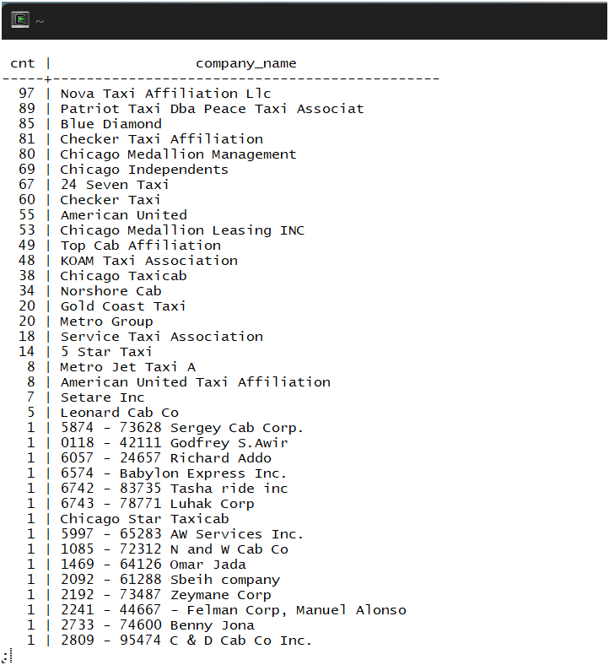

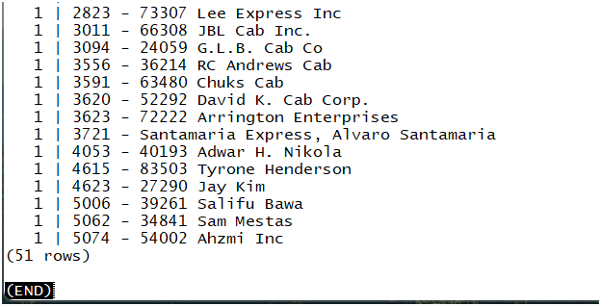

La solicitud que te ayudó a resolver la tarea.

## 

## **Ejercicio 3**

La tabla con los datos para el periodo especificado. Poner una estampa en las fechas de acuerdo a su clima registrado, en un periodo específico.

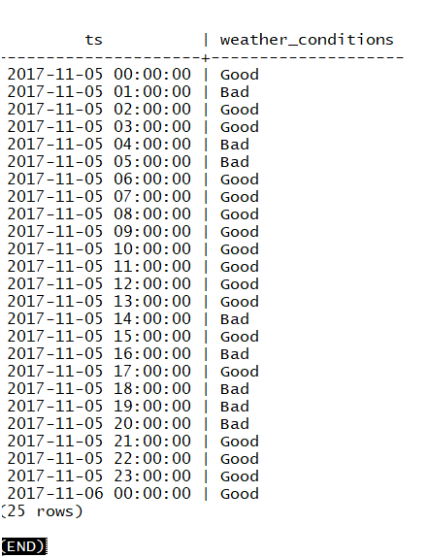

La solicitud que utilizaste para resolver la tarea.

## 

## **Ejercicio 4**

La tabla con datos para contar los viajes de una compañía en un período específico.

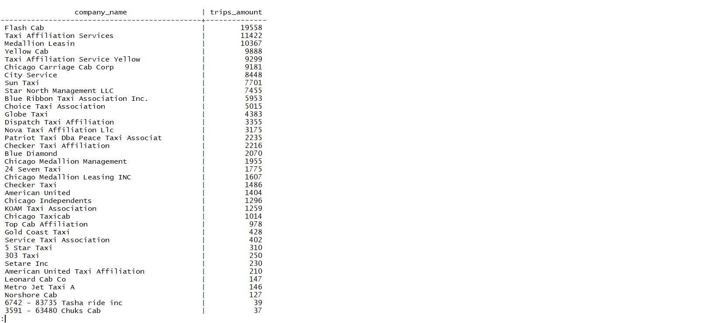

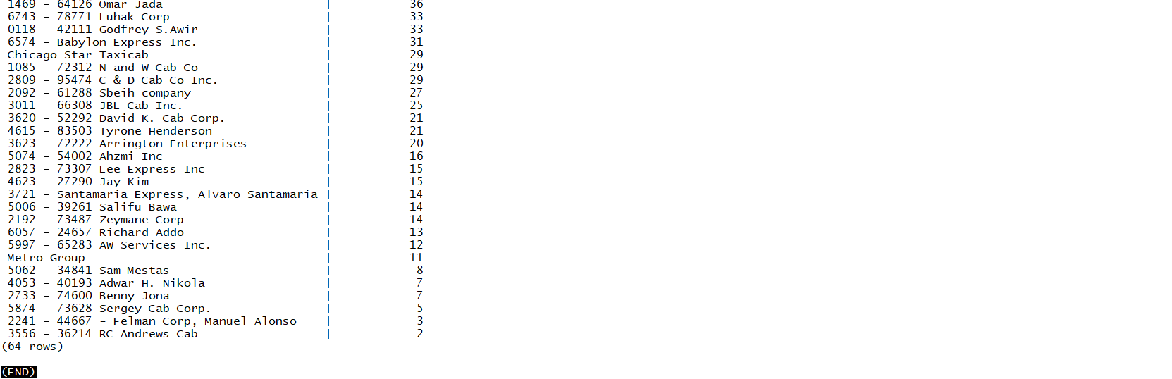

La solicitud que utilizaste para resolver la tarea.

